SMART LIBRARY REQUEST WORKFLOW IN SERVICENOW

SUBMITTED BY

5F77FE6EB7A60C7A6A44A758D1B18BA0 BHUVANESHWARI V

D3EF40D6C150B05B16C4CC4EB3984AAC DHANALAKSHMI S

B6B2240C4A61C50B6314B6612D6FF9A0 DHARSHINI K

33B4E2AB10FB7EF8A0A4A9EC587C9BCC FRANCINA S

ABSTRACT

Libraries are one of the most important knowledge centre’s in educational institutions, providing students, faculty, and researchers with access to a wide range of books, journals, and digital resources. Despite the growth of technology, many libraries still rely on traditional manual methods to manage book requests, issue records, and approval processes. These manual systems often lead to several challenges such as delays in processing requests, difficulty in maintaining records, lack of transparency, and increased workload for library staff. In addition, tracking book availability and monitoring user requests becomes time-consuming and inefficient.
The Smart Library Request Workflow in ServiceNow project aims to address these challenges by implementing an automated request management system using the ServiceNow platform. ServiceNow is a powerful cloud-based platform that allows organizations to design workflows, automate processes, and manage requests efficiently. By utilizing the capabilities of ServiceNow, the proposed system provides a structured and user-friendly method for handling library requests and approvals.
In this system, users such as students or faculty members can submit book requests through a digital interface. Once a request is submitted, it is automatically forwarded to the librarian for review and approval through a predefined workflow. The librarian can then verify the availability of the requested book and approve or reject the request accordingly. The system also maintains records of all requests, approvals, and transactions, ensuring proper documentation and easy retrieval of information whenever required.
Another key feature of the system is the ability for administrators to monitor library activities and track request statistics. This helps in improving decision-making, identifying frequently requested books, and managing library resources more effectively. The automation provided by ServiceNow reduces manual paperwork, minimizes errors, and improves the overall efficiency of the library management process.
The Smart Library Request Workflow not only enhances operational efficiency but also improves the user experience by providing faster request processing and better transparency in the approval process. By integrating modern workflow automation into traditional library management practices, this project demonstrates how digital transformation can significantly improve the management of educational resources.
Overall, the proposed system contributes to a more organized, efficient, and reliable library management environment, benefiting both users and library staff while supporting the goals of modern educational institutions.

Introduction

Libraries play an important role in educational institutions by providing access to books, journals, and other learning resources. However, many libraries still depend on traditional manual methods to manage book records, borrowing requests, and approvals. These manual processes can lead to inefficiencies, delays, and difficulty in tracking library activities.
The Smart Library Request Workflow in ServiceNow project aims to modernize the traditional library management process by implementing an automated workflow system. By using the ServiceNow platform, the project focuses on improving the way users request books, how librarians manage approvals, and how administrators monitor library usage.
This phase identifies the existing problems in the traditional system and defines the objectives of the proposed solution.

1. Need for the System
Traditional library management systems mainly depend on manual processes such as maintaining registers for book requests, issuing, and returning books. These methods are time-consuming and may lead to errors in record keeping. As the number of users and library resources increases, it becomes difficult for librarians to manage requests efficiently. Therefore, there is a strong need for an automated system that can simplify library operations and improve overall efficiency.

2. Challenges in the Existing System
Many libraries face several challenges due to manual management practices. These include delays in processing book requests, difficulty in tracking book availability, and lack of proper communication between users and librarians. In addition, maintaining physical records increases the risk of data loss and makes it harder to retrieve information quickly when required.

3. Role of Automation in Library Management
Automation plays a significant role in improving the efficiency of library systems. By implementing automated workflows, libraries can reduce manual effort, minimize errors, and speed up the request approval process. Digital systems also make it easier to store, access, and manage data in a more organized manner.

4. Importance of ServiceNow Platform
ServiceNow is a powerful cloud-based platform designed for workflow automation and service management. It allows organizations to create customized workflows, manage requests, and track activities effectively. Using ServiceNow in library management helps streamline processes such as book request submission, approval workflows, and record tracking.

5. Benefits of the Proposed System
The Smart Library Request Workflow provides several benefits such as faster request processing, better transparency, improved record management, and reduced paperwork. It helps both library users and staff by providing an easy and efficient way to handle book requests and approvals.

Problem Statement

In many institutions, the library management process involves manual record keeping or basic digital systems that do not support automated workflows. This creates several challenges for both library staff and users.
One major issue is the lack of real-time information about book availability. Students may request books that are already issued to others, and librarians must manually check records to verify availability.
Another challenge is the inefficient approval process. When a student requests a book, the request may need to be reviewed and approved by a librarian or administrator. Without automation, this process can be slow and prone to errors.
Additionally, manual systems provide limited visibility into borrowing patterns and library usage. Library administrators may find it difficult to analyze which books are most popular or how frequently books are borrowed.
Manual data entry can also result in data inconsistencies, duplication, and loss of information. Maintaining physical records or spreadsheets increases the risk of mistakes and makes reporting difficult.
Example 1
In a traditional library system, a student fills out a paper form to request a book. The librarian checks a register to confirm whether the book is available. If the book is
available, the librarian manually records the borrowing details in a notebook. This process takes time and may lead to errors if the records are not updated properly.

Objectives of the Project

• To develop an automated library request system using the ServiceNow platform to improve the efficiency of library operations.
• To simplify the process of requesting books by allowing users to submit requests through a digital interface.
• To implement a structured workflow that allows librarians to review, approve, or reject book requests easily.
• To reduce manual paperwork and minimize errors in maintaining library records.
• To improve transparency by allowing users to track the status of their book requests.
• To help administrators monitor library activities, manage records, and analyze request data effectively.
• To enhance the overall user experience by providing a faster and more reliable library service.
• To demonstrate how workflow automation using ServiceNow can modernize traditional library management systems.

Scope of the Project

The Smart Library Request Workflow in ServiceNow project focuses on developing an automated system to manage library book requests and approval processes efficiently. The scope of this project includes designing and implementing a workflow within the ServiceNow platform that allows users to submit book requests digitally instead of using manual methods.
The system enables students and faculty members to request books through an online interface. Once a request is submitted, the system automatically forwards it to the librarian for verification and approval. The librarian can then check the availability of the requested book and approve or reject the request accordingly. This workflow helps in reducing delays and improving communication between users and library staff.
The project also includes maintaining digital records of book requests, approvals, and transactions. These records can be easily accessed and managed by the library administrator for monitoring and reporting purposes. The system helps track the number of requests, approved books, and other library activities.
In addition, the project aims to improve transparency and efficiency in library management by reducing manual paperwork and simplifying the request handling process. However, the scope of this project is limited to managing book request workflows and approvals within the ServiceNow environment. Advanced features such as full digital library systems, online book reading, or integration with external library databases are not included in this project.
Overall, the project demonstrates how workflow automation using ServiceNow can enhance the efficiency and organization of library management systems in educational institutions.

Tools and Technologies Used

The Smart Library Request Workflow in ServiceNow project uses various tools and technologies to design, develop, and manage the automated library request system. These tools help in creating workflows, managing requests, and maintaining records efficiently.
1. ServiceNow Platform
ServiceNow is the main platform used in this project. It is a cloud-based service management tool that helps in creating automated workflows, managing requests, and handling approvals. It allows users to design forms, workflows, and dashboards for efficient request management.
2. ServiceNow Flow Designer
Flow Designer is used to create automated workflows within the ServiceNow platform. It helps in designing the process where book requests are automatically forwarded to the librarian for approval and further actions.
3. ServiceNow Studio
ServiceNow Studio is used as the development environment to build and customize applications within the ServiceNow platform. It helps developers create tables, forms, and application components required for the project.
4. ServiceNow Tables and Forms
Tables are used to store data related to book requests, user details, and approval records. Forms are used as the interface through which users submit book requests and librarians manage approvals.
5. Web Browser
A web browser such as Google Chrome or Microsoft Edge is used to access the ServiceNow platform and interact with the system.
6. Internet Connectivity
Since ServiceNow is a cloud-based platform, internet connectivity is required to access and manage the library request workflow system.
These tools and technologies work together to build an efficient automated system that simplifies the library request and approval process.

Project Phase

1. Identification Phase
Libraries play an important role in educational institutions by providing access to books, journals, and other learning resources. However, many libraries still depend on traditional manual methods to manage book records, borrowing requests, and approvals. These manual processes can lead to inefficiencies, delays, and difficulty in tracking library activities.
The Smart Library Request Workflow in ServiceNow project aims to modernize the traditional library management process by implementing an automated workflow system. By using the ServiceNow platform, the project focuses on improving the way users request books, how librarians manage approvals, and how administrators monitor library usage.
This phase identifies the existing problems in the traditional system and defines the objectives of the proposed solution.

2. Project Planning Phase
The Project Planning Phase is an essential step in the development of the Smart Library Request Workflow in ServiceNow. In this phase, the overall project structure, timeline, and implementation strategy are defined. Proper planning ensures that the system is developed in an organized and systematic manner.
This phase includes defining project milestones, identifying stakeholders involved in the project, and creating a step-by-step roadmap for the implementation process. Effective planning helps reduce risks, improves coordination among participants, and ensures that the project objectives are achieved successfully.

3. Project Design Phase
The Project Design Phase focuses on defining the structure and user interface of the Smart Library Request Workflow in ServiceNow. During this phase, the system’s database tables, user interface behavior, and security controls are carefully designed to ensure smooth functionality and proper data management.
The design process includes creating structured tables to store book information, improving the user interface through UI policies, and implementing access control mechanisms to protect sensitive data. A well-designed system helps ensure that the application is easy to use, secure, and efficient.

4.Workflow Automation
One of the most important parts of the system is the workflow automation that manages the book borrowing process. ServiceNow’s Flow Designer is used to automate actions when specific events occur in the system.
When a student submits a borrow request, the request enters the workflow and waits for librarian approval. Once the librarian reviews and approves the request, the workflow automatically updates the book status to “Issued.”
This automation eliminates the need for librarians to manually update book records, reducing errors and saving time.

5. Project Documentation Phase
The Project Documentation Phase is an important part of the Smart Library Request Workflow in ServiceNow project. Documentation helps explain how the system is designed, developed, and implemented so that other developers, administrators, or users can understand and reproduce the system if needed.
Proper documentation ensures that the project is easy to maintain, update, and deploy in different environments. In this phase, the project includes two main documentation components: the Technical Blueprint and the Setup Manual.

6. Project Demonstration Phase
The Project Demonstration Phase is used to present how the Smart Library Request Workflow in ServiceNow works in a real-time environment. This phase shows the complete working process of the system from the user perspective. It helps stakeholders, instructors, and evaluators understand how the system functions and how it improves the library management process.
The demonstration mainly includes three parts: Portal Walkthrough, Workflow Execution, and Reporting Dashboard. These components display the system’s features and how different users interact with the platform.

System Architecture and Workflow

The Smart Library Request Workflow in ServiceNow system is designed to automate the process of requesting, approving, and managing library books. The system architecture consists of different components that work together to ensure smooth communication between users, librarians, and administrators.
The architecture mainly includes three major components: User Interface, ServiceNow Application Layer, and Database Layer.
1. User Interface (UI)
The User Interface is the front-end part of the system where users interact with the application. Students or faculty members can access the system through the ServiceNow portal and submit book requests by filling out a request form. The interface allows users to enter details such as book name, author, and other necessary information.
2. ServiceNow Application Layer
This layer handles the main functionality of the system. It manages the workflow automation using ServiceNow features such as Flow Designer, forms, and request management. When a user submits a request, the workflow automatically sends the request to the librarian for review. The librarian can then approve or reject the request based on the availability of the book.
3. Database Layer
The database layer stores all the information related to book requests, user details, approval status, and transaction records. ServiceNow tables are used to maintain this data securely and allow easy retrieval whenever required.
Workflow of the System
The workflow of the Smart Library Request system follows a structured process:
- The user logs into the ServiceNow portal.
- The user fills out the book request form and submits the request.
- The request is automatically recorded in the ServiceNow database.
- The system forwards the request to the librarian for verification.
- The librarian checks the availability of the requested book.
- The librarian approves or rejects the request.
- The user receives a notification about the status of the request.
- The administrator can monitor all requests and maintain records for future reference.
This architecture and workflow ensure that the entire library request process becomes faster, more organized, and easier to manage compared to traditional manual systems.

SCREENSHOTS

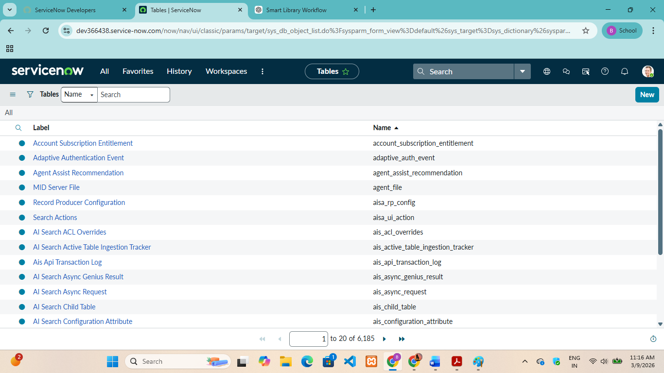

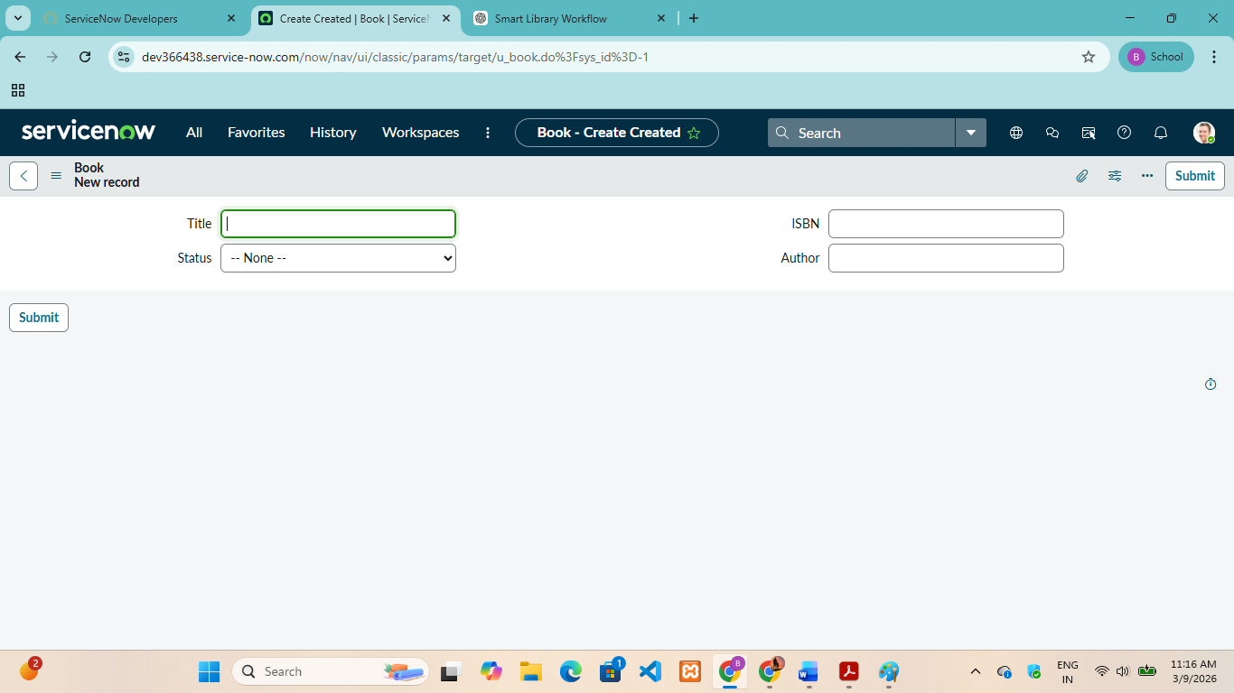
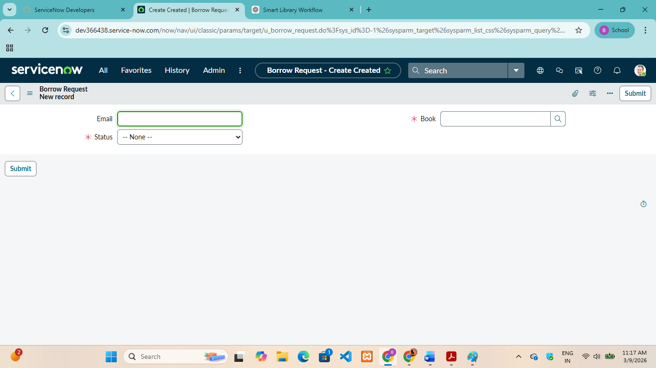

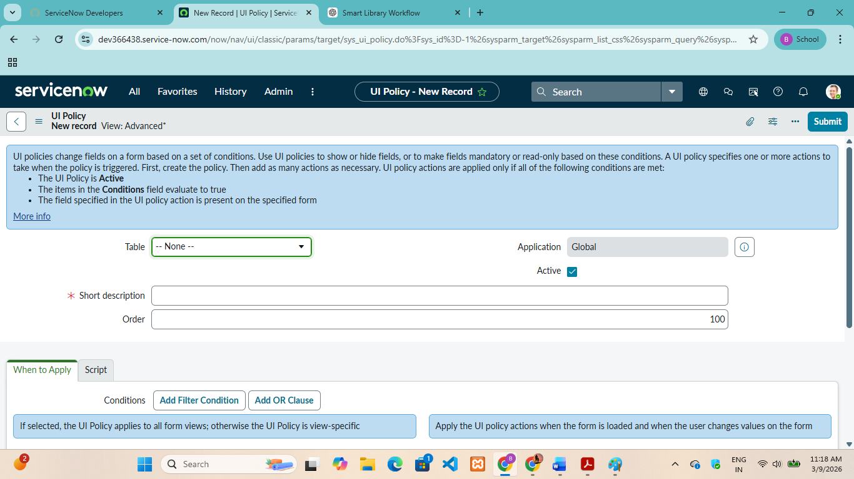
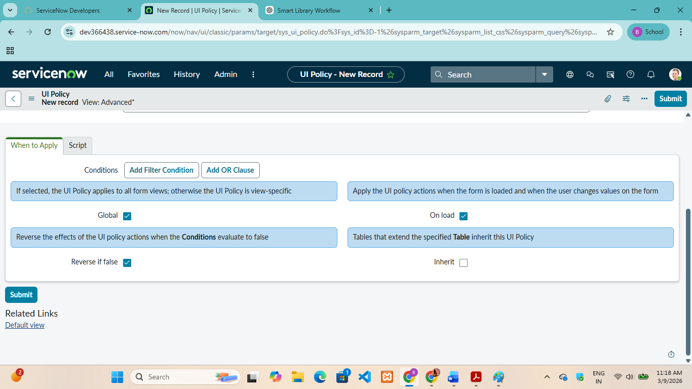

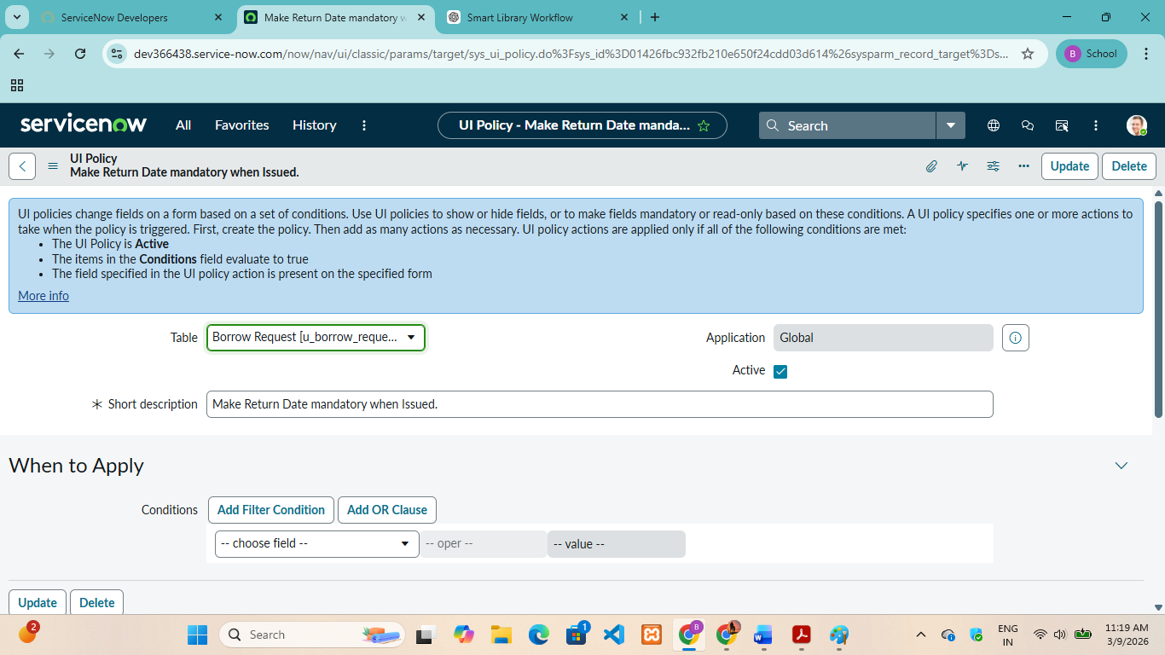
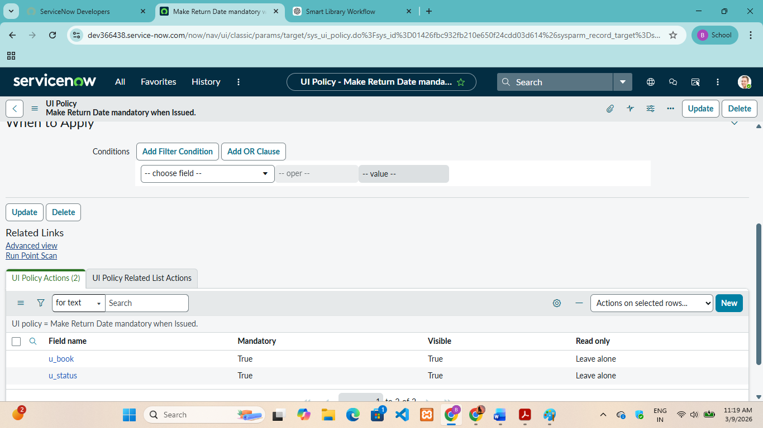

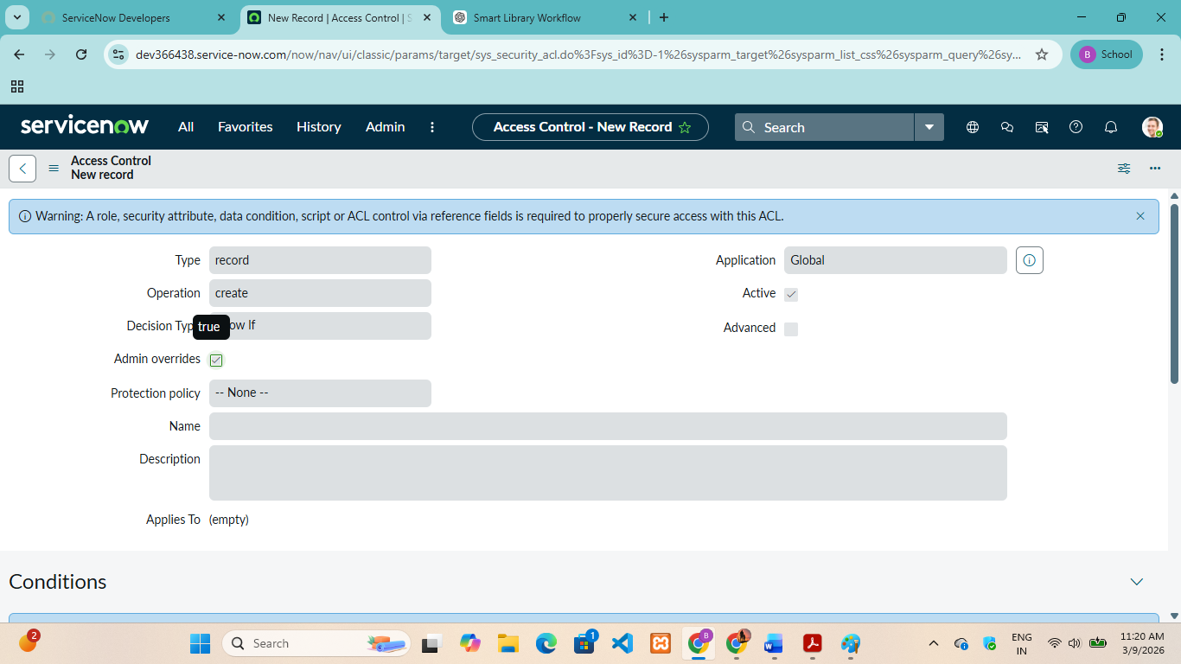
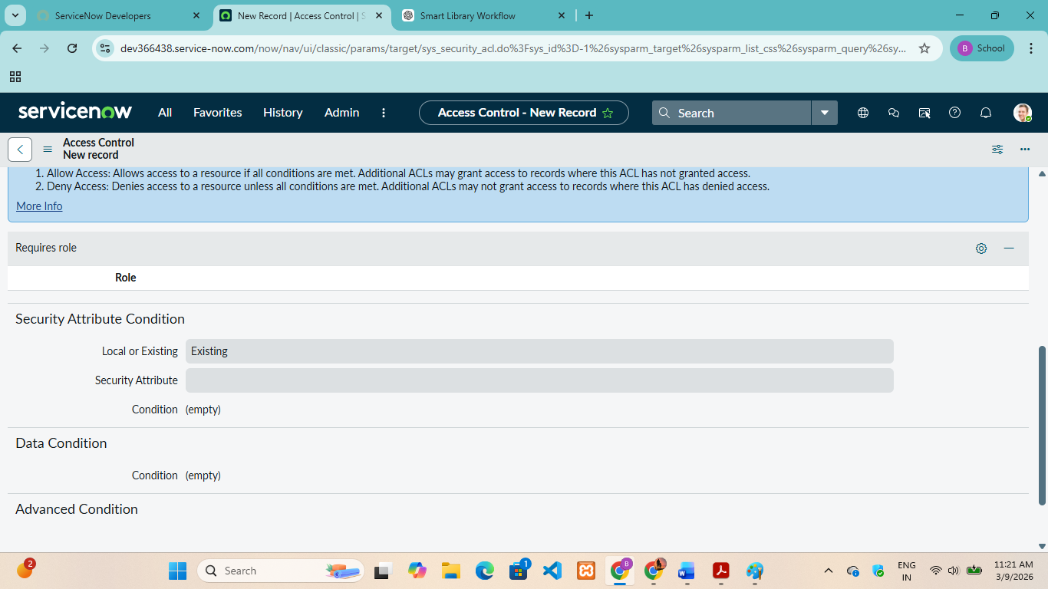

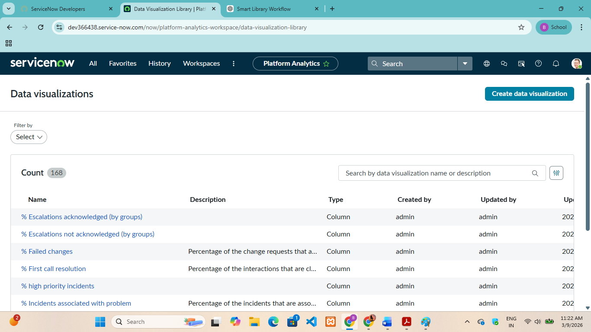

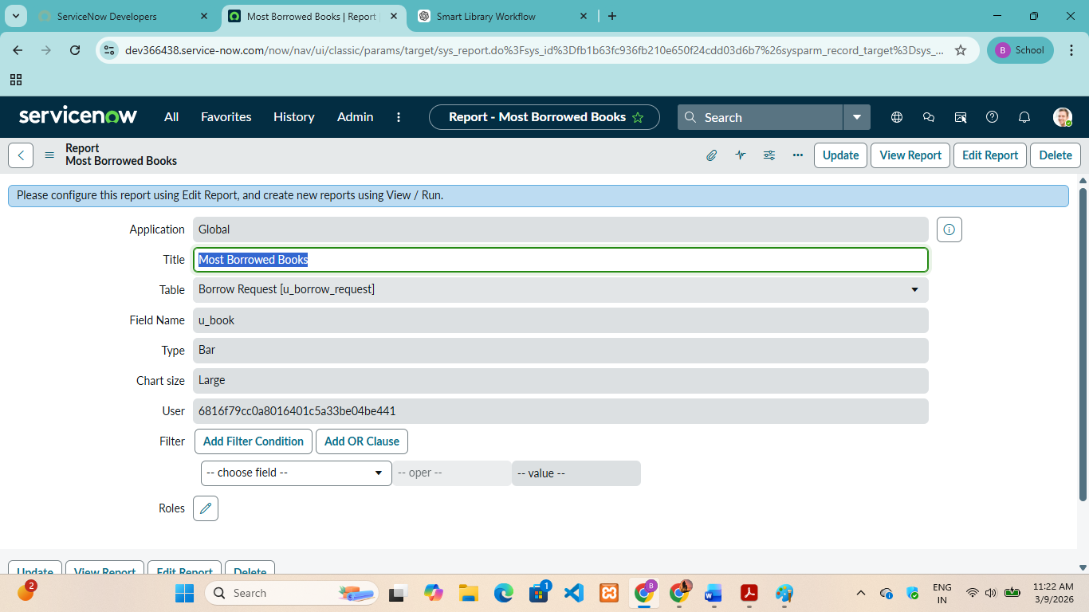

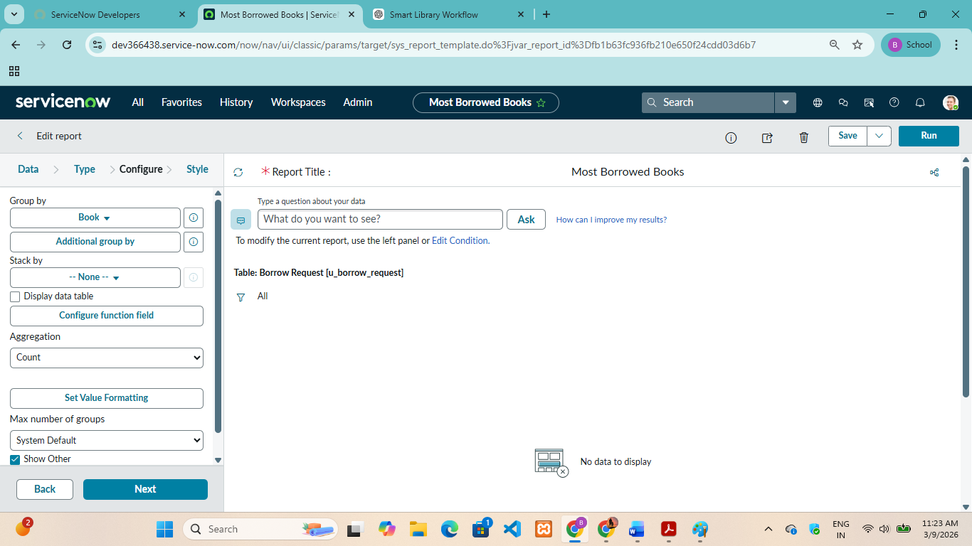

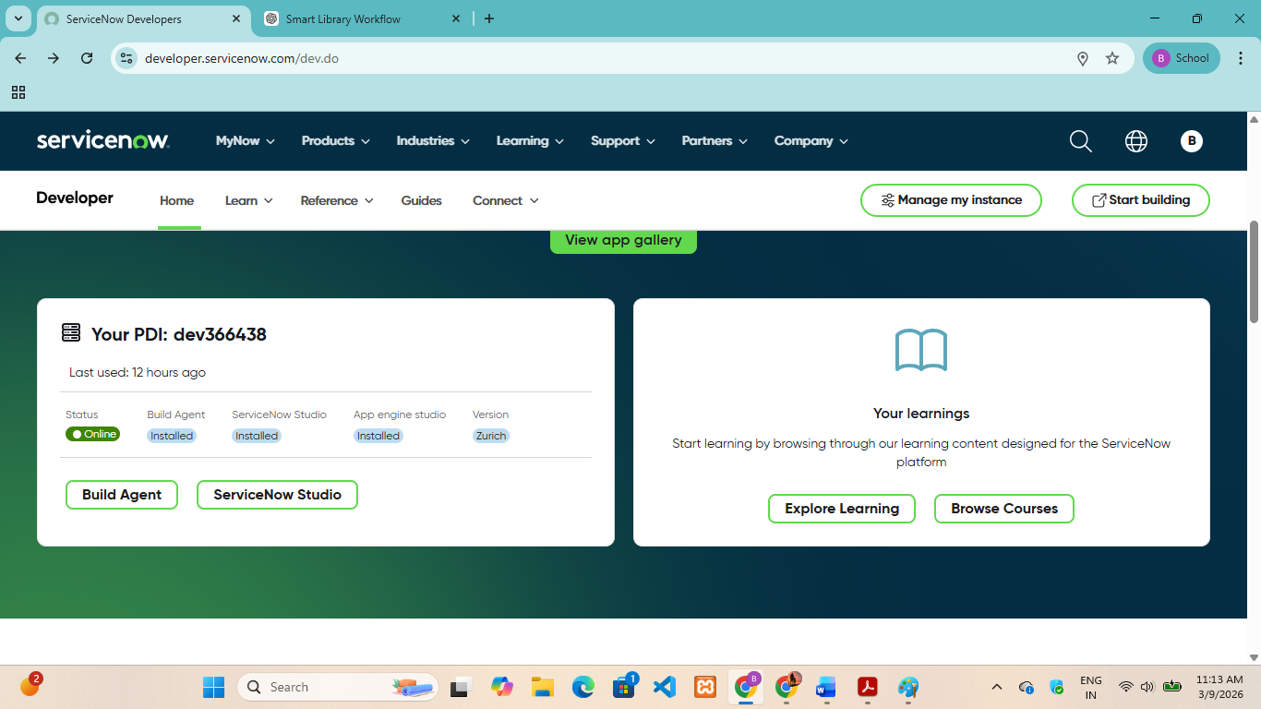

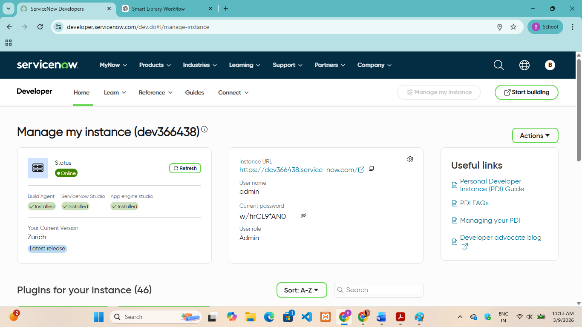

Limitations of the System

Although the Smart Library Request Workflow in ServiceNow system improves the efficiency of library management, it still has some limitations.
1. Internet Dependency
Since the system is based on the ServiceNow cloud platform, it requires a stable internet connection to access and use the system. Without internet connectivity, users cannot submit or track book requests.
2. Limited to Request Management
The system mainly focuses on managing book requests and approval workflows. It does not include advanced library features such as online book reading, digital library access, or full inventory management.
3. Training Requirement
Library staff and users may need basic training to understand how to use the ServiceNow platform and its features effectively.
4. Initial Setup Complexity
Setting up workflows, forms, and tables in ServiceNow may require technical knowledge and time during the initial development stage.
5. Dependence on Platform Availability
The system depends on the availability and performance of the ServiceNow platform. Any technical issues or maintenance in the platform may temporarily affect system access.
Despite these limitations, the system still provides an efficient and organized approach to handling library requests compared to traditional manual methods.

Future Enhancements

The Smart Library Request Workflow in ServiceNow system can be further improved by adding several advanced features in the future to enhance its functionality and user experience.
1. Integration with Digital Library Systems
The system can be integrated with digital libraries to allow users to access e-books, journals, and other online learning resources directly through the platform.
2. Real-Time Book Availability Tracking
Future versions of the system can include a feature that shows real-time book availability, helping users check whether a book is available before submitting a request.
3. Mobile Application Support
A mobile application can be developed so that users can easily request books, track request status, and receive notifications through their smartphones.
4. Notification and Alert System
The system can be enhanced with automated email or SMS notifications to inform users about request approvals, rejections, or book return reminders.
5. Advanced Reporting and Analytics
Administrators can be provided with advanced analytics and reporting tools to analyze library usage, identify frequently requested books, and make better decisions for library resource management.
6. Barcode or QR Code Integration
Future improvements can include barcode or QR code scanning for faster book issuing and returning processes.
7. Multi-Library Support
The system can be expanded to support multiple libraries within an institution, allowing users to request books from different library branches.
These future enhancements can make the system more advanced, efficient, and capable of meeting the growing needs of modern educational institutions.

Conclusion

The Smart Library Request Workflow in ServiceNow project focuses on improving traditional library management by introducing an automated workflow system. In many educational institutions, library processes such as book requests, approvals, and record management are still handled manually, which can lead to delays, errors, and inefficiencies. By implementing this system on the ServiceNow platform, the project aims to simplify and streamline these processes.
The system allows users to submit book requests through an online interface, while librarians can easily review and manage these requests through an organized approval workflow. It also helps administrators monitor library activities and maintain proper records of all transactions. This automation reduces manual work, improves transparency, and ensures faster processing of requests.
Overall, the project demonstrates how workflow automation can enhance the efficiency and effectiveness of library management systems. The Smart Library Request Workflow provides a more organized, reliable, and user-friendly approach to handling library requests, benefiting both users and library staff. With further improvements and additional features in the future, the system can become a more comprehensive solution for modern library management.

